IT24103799
Amarasingha D I B
SLIIT – Malabe
Probability and statistics – IT2120
Lab 09
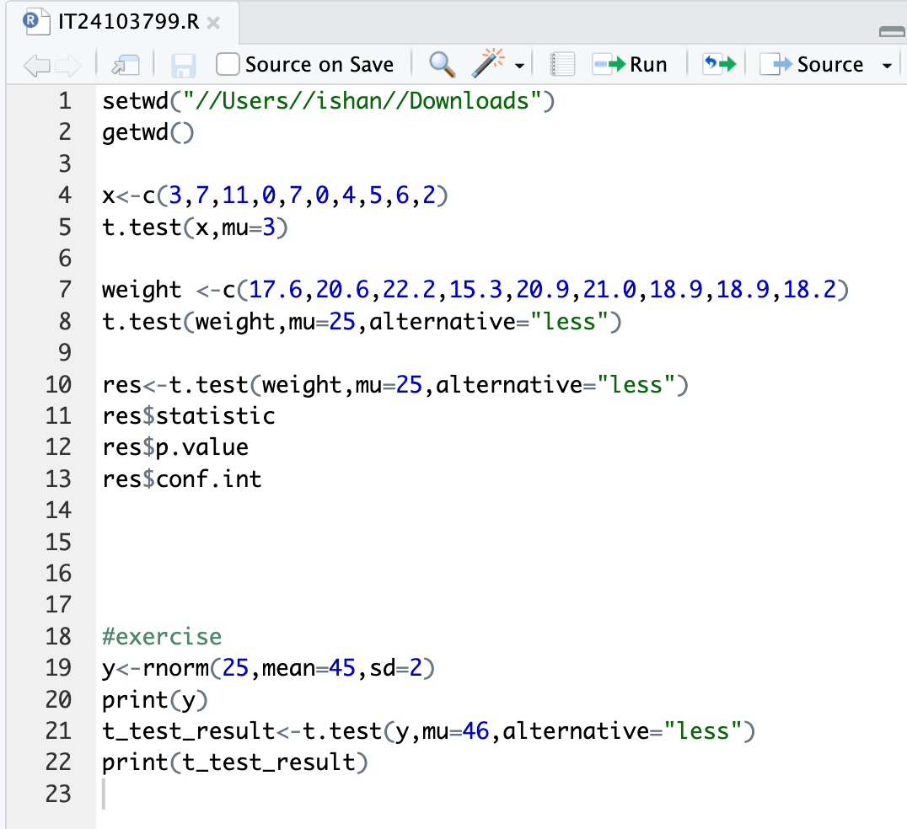

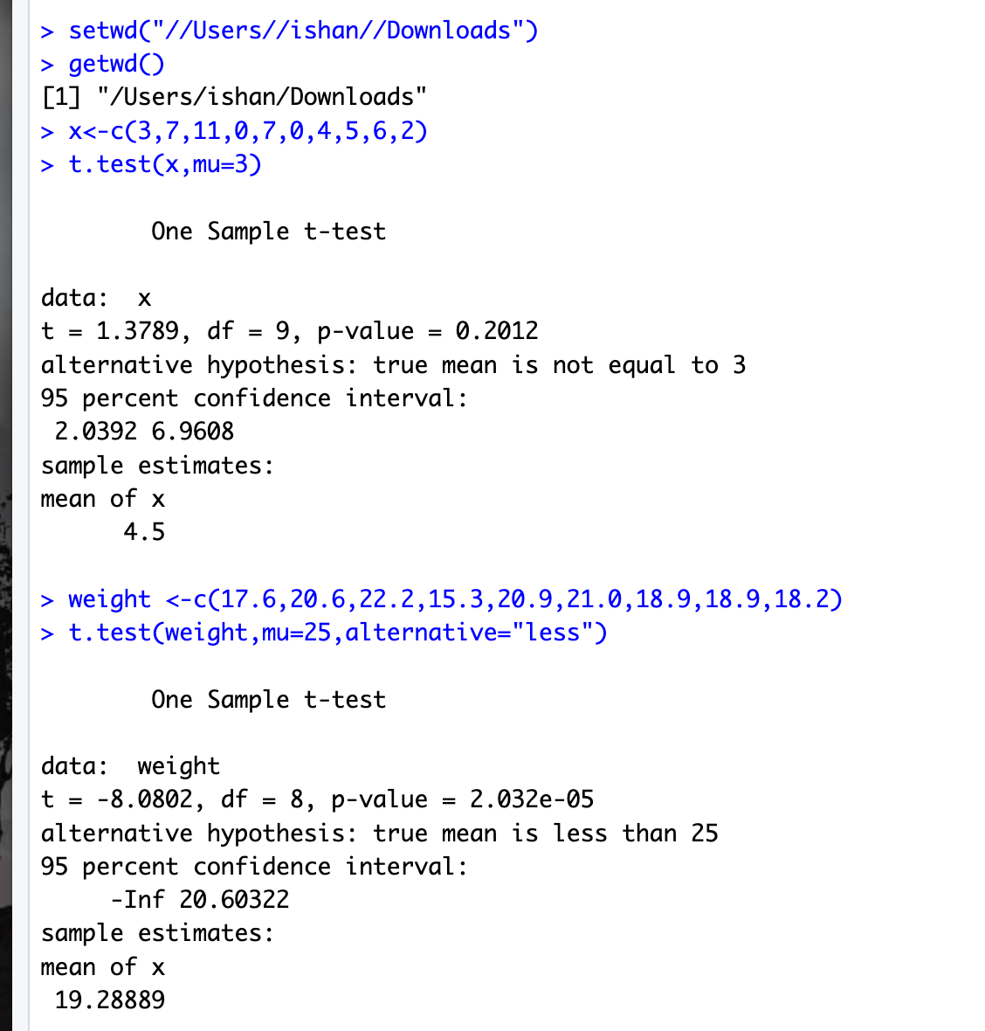
Output

